

**SUPREME STUDENT COUNCIL PORTFOLIO**

**FIRST SEMESTER**

**AY: 2023 – 2024**

**DECEMBER 14, 2023**

**TABLE OF CONTENTS**

**CONTENT PAGE**

Introduction i

Club Members ii

CBL iv

Accomplished Activities v

Evaluation xii

Liquidation Report xvii

Proposed Calendar of Activities xxvii

Proposed Activities xxviii

**INTRODUCTION**

The Supreme Student Council (SSC) is a dynamic and influential student-led organization and considered as the mother of all the school club organizations inside the campus that plays a pivotal role in fostering leadership, representation, and positive change within the institution. Composed of dedicated and elected student officials, the SSC serves as a bridge between students, faculty, school orgs, and administration, working collaboratively to enhance the overall student experience and contribute to a friendly learning environment.

SSC serves as a voice of the student body representing their opinions and concerns to the school administration. The SSC takes the lead in planning and organizing school events which aims school’s and student's welfare and development. The council also collaborates with school administrators and other clubs to discuss and implement changes that will uphold productivity and academic-related support.

As the central governing body of the school, the Supreme Student Council serves as the brain of all school club organizations which are responsible for overseeing their activities, coordinating resources, and promoting collaboration, approving and recognizing clubs, allocating resources, providing training, advocating for club interests, promoting diversity, acting as a communication hub, and evaluating and recognizing club achievements.

To sum up, the Supreme Student Council stands as a dedicated group of elected individuals, poised to empower and uplift the student community. Through their initiatives, the SSC endeavors to create a vibrant and harmonious school atmosphere, where the diverse voices and aspirations of students are not only heard but actively addressed. As a driving force for positive change, the SSC exemplifies the spirit of collaboration and leadership, contributing to the overall growth and success of the educational institution.

**Mission**: The Supreme Student Council (SSC) of New Brighton School of the Philippines Inc. (NBSPI) commits to providing the best quality of leadership which is beneficial for the students. The council is dedicated to giving a good service delivered with a sense of warmth, friendliness, and responsible action towards administration.

**Vision:** The Supreme Student Council (SSC) envisions a fully disciplined community that promotes advocacy about academic support, inclusivity, community engagement, and conflict resolution. They uphold the values of servant leadership for the welfare of the students to make New Brighton School of the Philippines Inc. (NBSPI) a friendly institution.

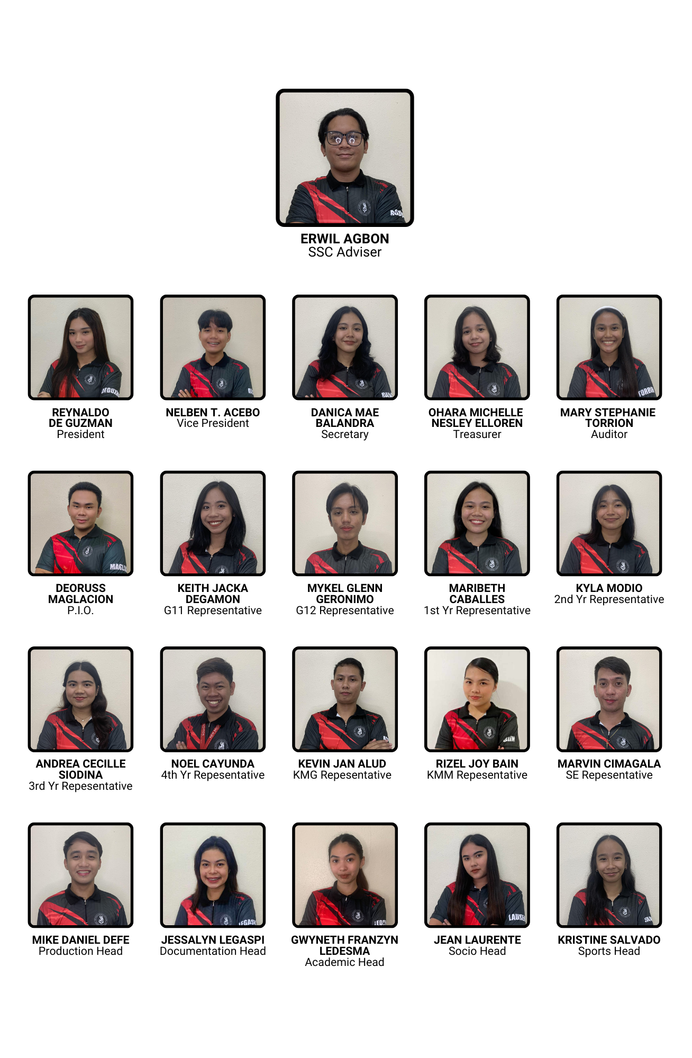**CLUB MEMBERS**

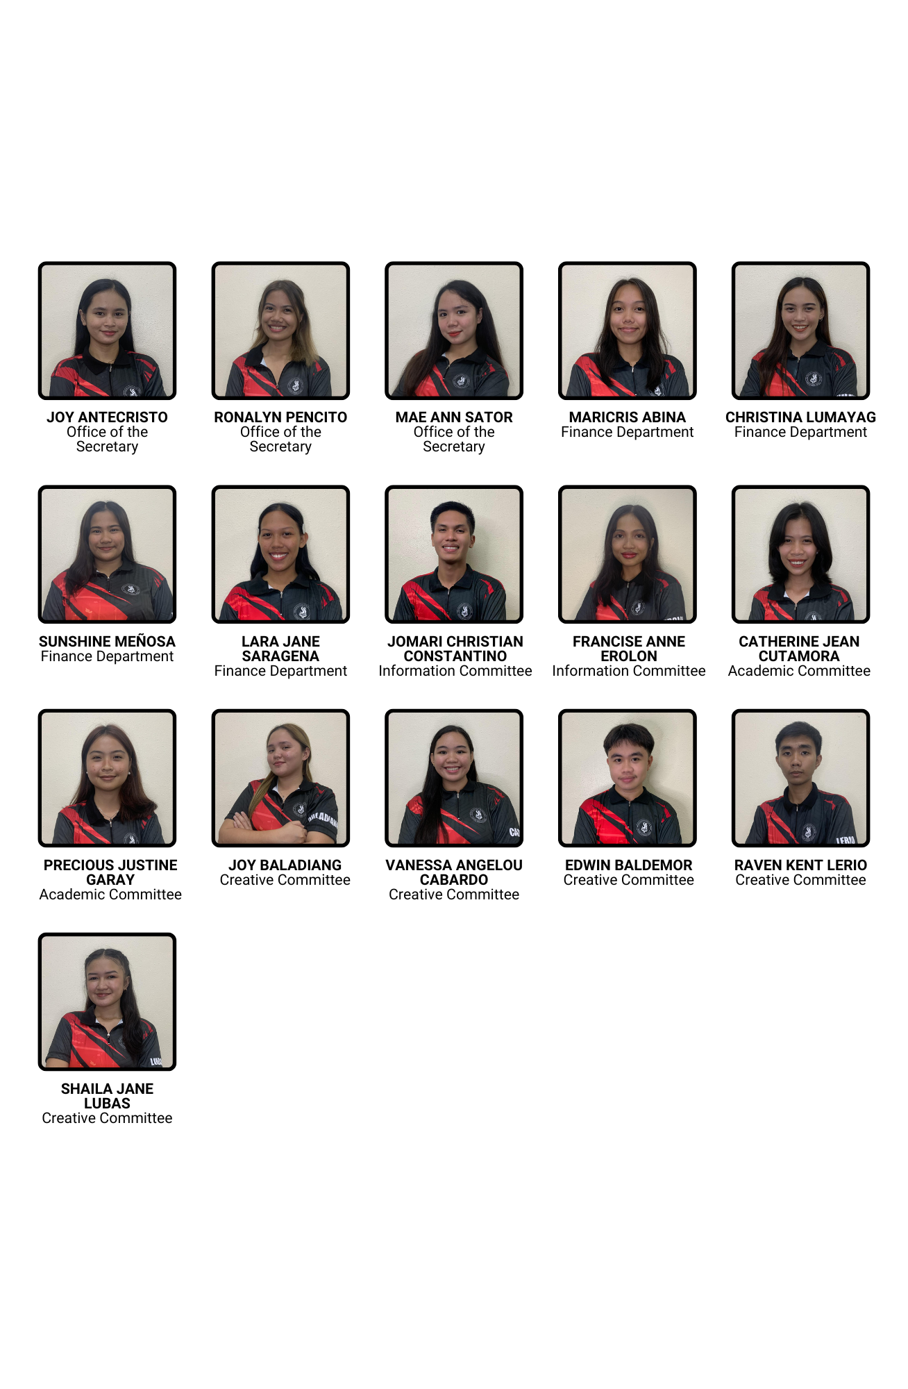

**CBL**

**ACCOMPLISHED ACTIVITIES**

**FIRST GENERAL ASSEMBLY**

**August 25, 2023**

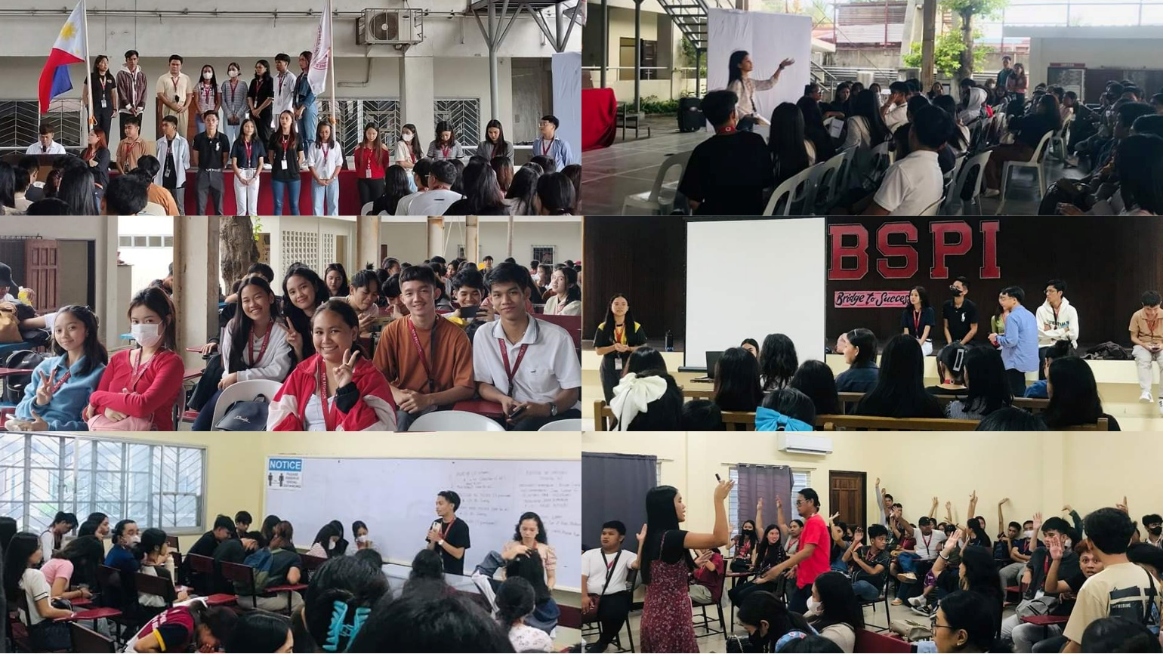

On August 25, a new group of SSC Officers held a General Assembly at the NBSPI Covered Court to plan and implement the first semester of the 2023-2024 school year. The assembly aimed to make decisions that would influence future events and activities. The assembly sparked fresh viewpoints and agreements, bonded the community together. The assembly ended under the direction of the Supreme Student Council and OSA coordinator.

**ACCOMPLISHED ACTIVITIES**

**SECOND GENERAL ASSEMBLY**

**September 28 and 29, 2023**

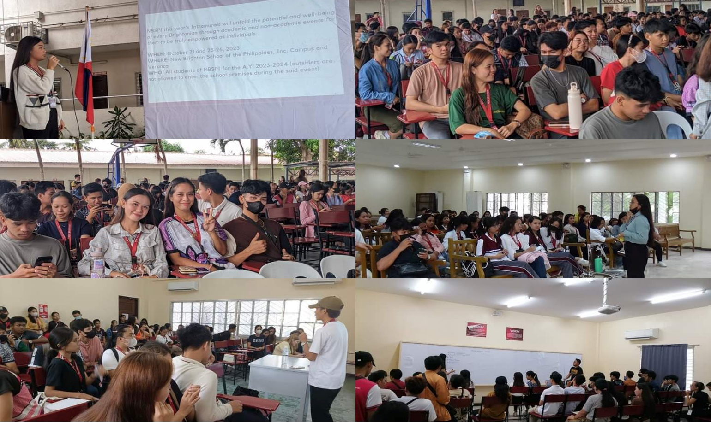

Our Second General Assembly was held at our school, New Brighton School of the Philippines, Inc., on the previous Thursday and Friday, September 28 and 29, 2023, which proved to be an informative and successful day.

We have scheduled separate sessions for regular students and student employees to make it more convenient for everyone. This division ensures that our hardworking Student Employees can fully engage with substance information to furnish answers regarding their concerns.

During this gathering, we discussed the institution's upcoming activities and events, such as the much-anticipated Brightest Night Gala and Pasiklaban 2023. Following the assembly, each division delved into their plans for Pasiklaban.

As students, we witnessed the significance of teamwork as we collaborated to pursue learning, development, and creativity. We explored bold strategies and initiatives aimed at enhancing our institution's operations and activities, under the guidance of the SSC of the school, with assistance from Ms. Romelyn Bitayo, the OSA coordinator, and Mr. Erwil Agbon, the SSC adviser.

We express our deepest gratitude to our school dean, Dr. Angelita C. Ty, for her unwavering support. Additionally, we extend our thanks to the school's faculty members, staff, and students who participated in the entire program.

**ACCOMPLISHED ACTIVITIES**

**ADHIKA | BUWAN NG WIKA 2023**

**September 03, 2023**

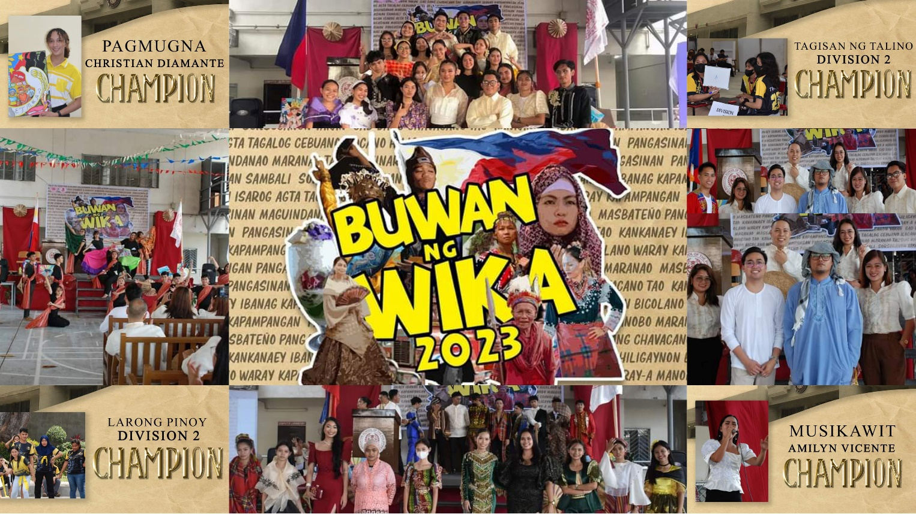

“𝑭𝒊𝒍𝒊𝒑𝒊𝒏𝒐 𝒂𝒕 𝒎𝒈𝒂 𝑲𝒂𝒕𝒖𝒕𝒖𝒃𝒐𝒏𝒈 𝑾𝒊𝒌𝒂: 𝑾𝒊𝒌𝒂 𝒏𝒈 𝑲𝒂𝒑𝒂𝒚𝒂𝒑𝒂𝒂𝒏, 𝑺𝒆𝒈𝒖𝒓𝒊𝒅𝒂𝒅, 𝒂𝒕 𝑰𝒏𝒈𝒌𝒍𝒖𝒔𝒊𝒃𝒐𝒏𝒈 𝑷𝒂𝒈𝒑𝒂𝒑𝒂𝒕𝒖𝒑𝒂𝒅 𝒏𝒈 𝑲𝒂𝒕𝒂𝒓𝒖𝒏𝒈𝒂𝒏𝒈 𝑷𝒂𝒏𝒍𝒊𝒑𝒖𝒏𝒂𝒏.”

Ito ay pagkakataon na itaguyod ang mga wika ng iba't ibang rehiyon sa bansa, patunayang mas malalim ang kahulugan ng bawat salita at titik, at higit sa lahat, ito ay pagdiriwang ng ating pagkakaisa bilang isang bansa.

Sa pagdaraos ng buwan ng wika ay nagkaroon ng awit at pagsayaw, mga larong pinoy, sunod nito ay ang masining na pagmumugna na kasabay ang tagisan ng talino tungkol sa panitikan mula sa lahat ng sulok ng ating bansa.

Sa pagtatapos, isang makulay at masaya na Parada ng Lahi ang naganap. Dito ipinakita ng mga mag-aaral ang kahalagahan ng ating mga wika at kultura. Kasama ang mga mag-aaral at guro, nagkakaisa kami upang ipagmalaki ang aming mga tradisyon, kasaysayan, at wika. Sa bawat paso ng aming parada, isang kuwento ng pagkakaisa at pagmamahal sa bayan ang aming ibinahagi.

**ACCOMPLISHED ACTIVITIES**

**TEACHERS’ DAY**

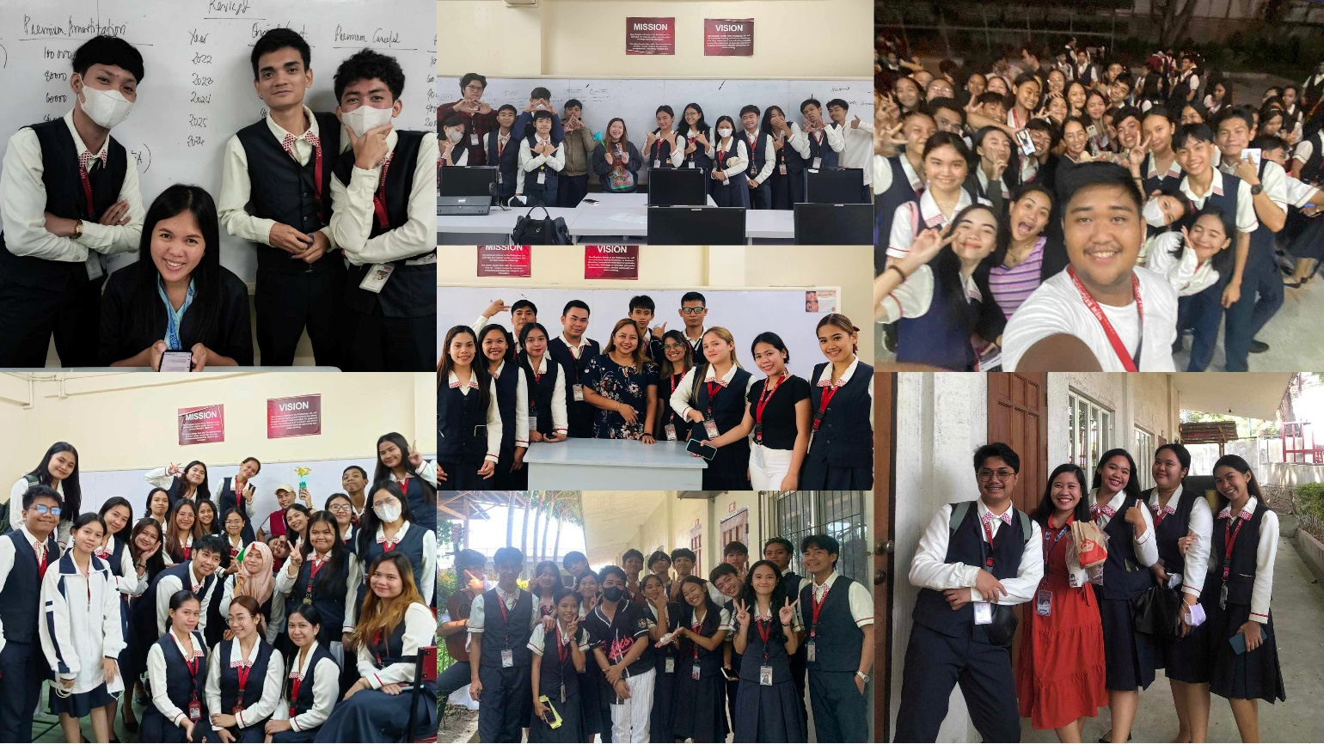**October 06, 2023**

The Teachers’ Day celebration last October 01, 2023 gives the students an opportunity to express their gratitude to NBSPI teachers. Some students gifted their mentors, while others conducted a program to honor their efforts. The celebration was deemed successful as students achieved their goal of honoring teachers.

**ACCOMPLISHED ACTIVITIES**

**PASIKLABAN 2023**

**October 21, 23-26, 2023**

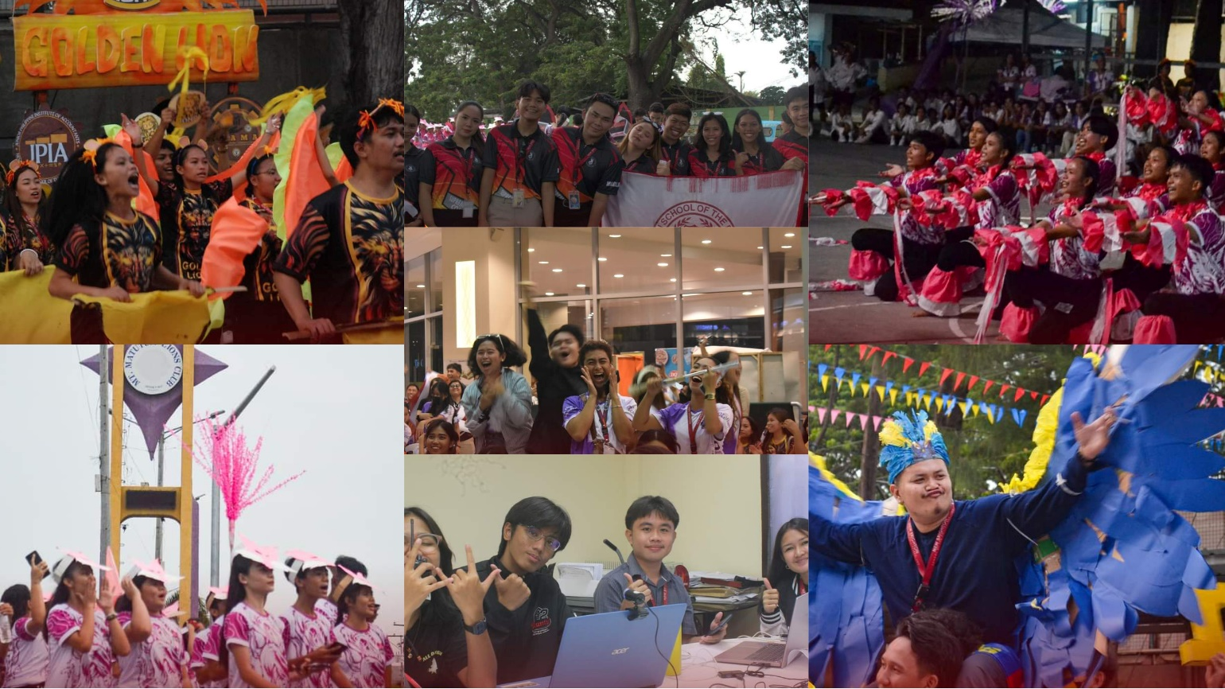

The NBSPI's intramurals, also known as Pasiklaban, are one of the highlights and most anticipated events of the semester. The said event was considered successful as it ended on a high note. Brightonians are able to share their greatness and talents while at the same time showing sportsmanship in every competition. The conclusion of Pasiklaban 2023 is a milestone that should be honored and remembered.

**ACCOMPLISHED ACTIVITIES**

**BRIGHTEST NIGHT GALA 2023**

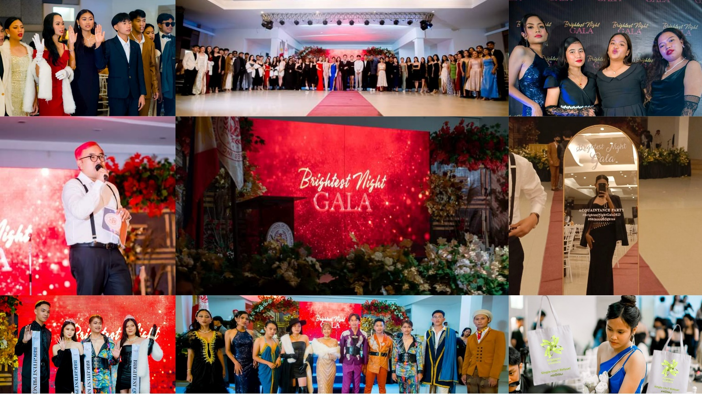**October 27, 2023**

Mr. Michael Carbon graced us with his presence, taking the stage as the master of ceremonies, igniting the enthusiasm of the students and the entire event. To commence the evening, the Office of Student Affairs (OSA) coordinator, Ms. Romelyn Bitayo, extended a warm welcome, setting the stage for an evening of grandeur. Following this, the Supreme Student Council (SSC) and various clubs within the institution participated in the oath-taking ceremony.

The launch of the souvenir, the "Brighton TOTE-fulness" Campaign (shortened to "BTOTEful") of Batch 2023-2024 NSTP Students—a continuation of the previous NSTP Students' Reject Plastic campaign—was presented by Mr. Erwil Agbon. The souvenirs were distributed by the SSC officers to the attendees. Prior to the event's official start, students eagerly seized the opportunity to capture gala-inspired moments by posing at the photo wall and showcasing their style in front of the arc mirror.

Among the attendees, some stood out as exceptional, earning accolades such as the Early Bird Award, Glamour Icon/Head Turner Award, and Gala Royalty Award (Brightest Prince, Princess, King, and Queen). Moreover, the event featured testimonials from selected students representing different divisions, adding depth and a personal touch to the gathering. To infuse a lighthearted atmosphere, entertaining games were incorporated, overseen by our Public Information Officer (P.I.O) and 4th Year Representative.

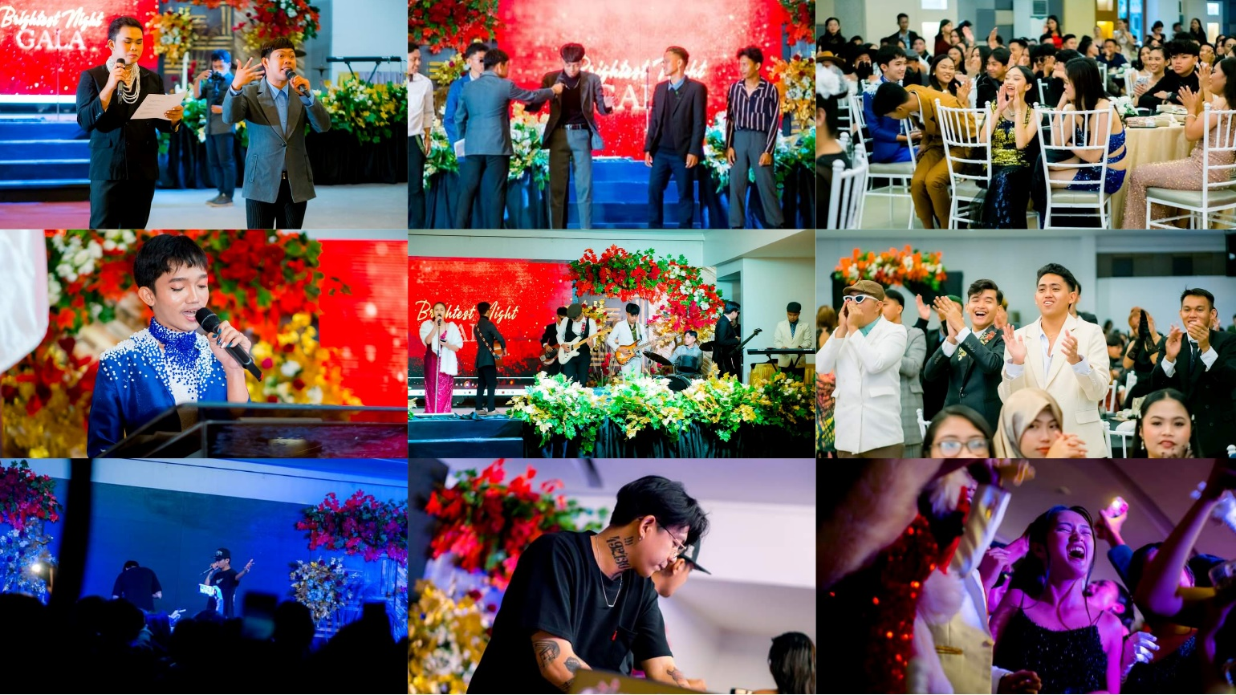

During dinner, the much-anticipated moment arrived as the Celestial band took center stage, enchanting everyone with their captivating performance featuring a new set of songs. Post-dinner, Chan’s Visuals (videographer and photographer of the night) unveiled their same-day-edit, a breathtaking compilation showcasing the gala's highlights. The impressive presentation garnered widespread admiration, especially from our advisor, who praised the remarkable editing skills. Subsequently, our guest DJ, Ezy Tellez, swept everyone away with his enchanting beats and charisma.

The night became a joyous celebration, leaving everyone yearning for more. The success of the gala owed much to the adept guidance and support from the OSA coordinator, SSC Adviser, SSC officers, institutional clubs and organizations (especially the Sirius Publication and Socio-cultural Club), School’s Dean, Principal, President, staff, administrators, faculty members, suppliers, collaborators, and, most especially, the Brightonians. As we look ahead to our future events, our commitment is to dedicate even greater effort to provide you with exceptional service and experiences. We are determined to continuously improve and ensure that each upcoming event surpasses expectations, aiming to deliver nothing short of our very best for your enjoyment and satisfaction.

Overall, under the celestial canopy, we shone our brightest. The night was an embodiment of grace, inspiration, and boundless joy. It fostered new connections and etched enduring memories. Here's to an unforgettable evening marked by timeless beauty and cherished moments. Cheers to an enchanting night that will forever remain etched in our hearts.

**EVALUATION**

**FIRST GENERAL ASSEMBLY**

**August 25, 2023**

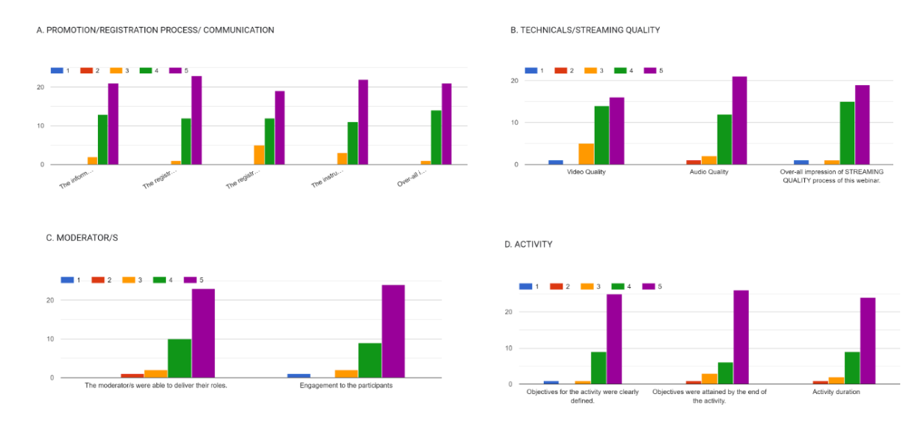

The 1st General Assembly ended with bright and shining attendees coming from different courses and year levels. The general assembly conducted for its purpose of allowing the students to be aware of what is coming. The said general assembly ended with a good impression by the students. However, there are some comments and opinions that need to be addressed in order to prevent further confusion.

Some students suggested having at least a couple of minutes break because it is tiring to sit for a long period of time. Additionally, some suggested to make the intermission number not to take too long and make the visual clearer. Moreover, the majority of the students left positive comments about the said general assembly.

**EVALUATION**

**SECOND GENERAL ASSEMBLY**

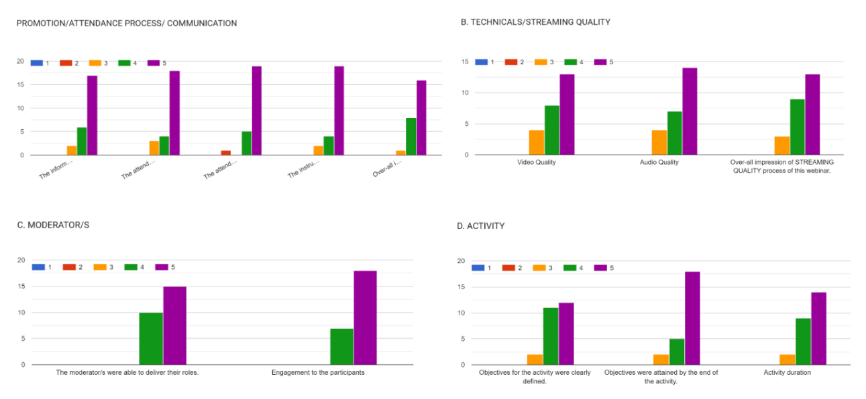**September 28 and 29, 2023**

The 2nd General Assembly happened on September 28 and 29, 2023 left a good impression. Students had the chance to be able to know what the next event would be and what they should expect. As the majority of the students left positive comments, there are some students who left comments that need to be assessed in order to close the gaps of misunderstanding.

Some students said they went to the school earlier yet they processed some papers that led them to not be able to sign their attendance, if possible, they could still get the chance to have their attendance being signed despite their absence during the given time of signing the attendance. Additionally, as the general assembly took a long period of time, they suggested it to be more entertaining. Overall, they appraised the general assembly because they understood it well and the moderators did their job well.

**EVALUATION**

**ADHIKA | BUWAN NG WIKA 2023**

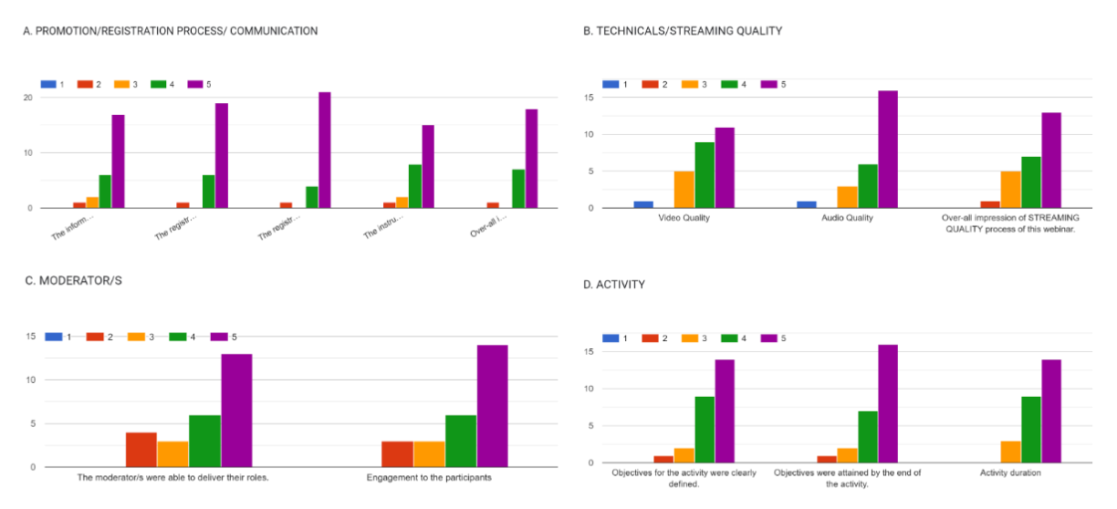**September 03, 2023**

Ang Buwan ng Wika ay isang selebrasyon upang gunitain ang mga wikang nag-uugnay sa mamamayang Pilipino at para na rin bigyang diin ang kahalagahan ng ating wika. Sa paggunita nito, inanyayahan ang bawat estudyante at mga guro na magsuot ng katutubong damit na siyang nag prepresenta sa kanilang lahi o nais lamang ipresenta. Ang bawat estudyante’t guro ay nabigyan ng pagkakataon upang irampa at ibahagi ang kanilang naggagandaha’t naggwawapohang mga kasuotan.

Sa pangyayaring ito, may iilang estudyante ang nagbigay ng kanilang opinyon sa takbo ng programa na kung saan may naglahad ng saloobin patungkol sa *alituntunin na kung saan hindi ito nabigyang klaro kaya’t nagkaroon ng pagkalito ang mga kalahok, at magkaiba rin daw ang alituntunin bago at noong nagsimula na ang laro.* May naglahad din ng opinyon patungkol sa pagkuha ng bidyo sa nasabing selebrasyon sapagkat may iilang kuha raw na *blurred at hindi maayos.* Karagdagan, sa parada ng lahi na kung saan nirampa ang mga kasuotan habang binibigyang oras ang mga estudyanteng rumampa habang kinukunan ng litrato’t larawan, may iilang nagbahagi na *nahiya sa ganoong parte ng programa* marahil na rin na may iilang estudyanteng hindi sanay sa ganoon, mainam na bigyang pansin ito. Kabuuhan, ang mga estudyante ay nagpahayag ng kanilang masaya at maligalig na opinyon sa nangyaring paggunita. Karamihan ay nagbigay puri sa mga taong nanguna sa selebrasyon at nagbigay apresasyon sa punong abala.

**EVALUATION**

**PASIKLABAN 2023**

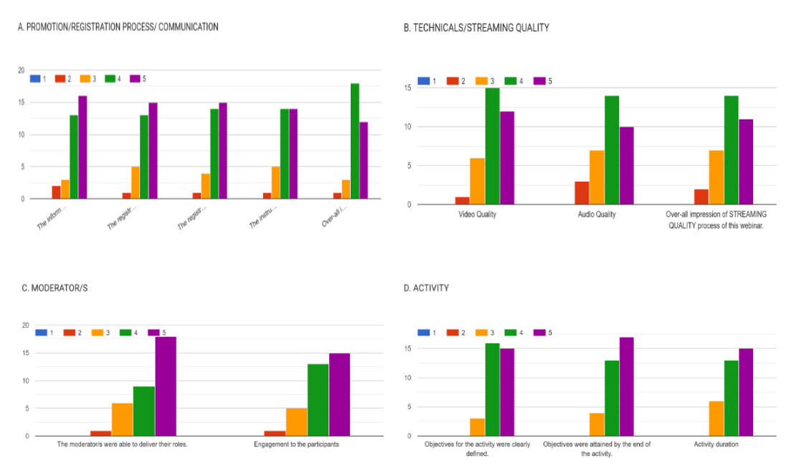**October 21 and 23-26, 2023**

Most respondents found the Pasiklaban 2023 enjoyable and well-organized. They appreciated the variety of activities but suggested adding new and exciting ones. Some had concerns about adhering to schedules and suggested better coordination among divisions to prevent delays. Others mentioned the need for clearer communication, especially regarding restrictions and preparations for activities. Overall, the majority had a positive experience, praising the event's planning and support system, while a few expressed areas for improvement.

**EVALUATION**

**BRIGHTEST NIGHT GALA 2023**

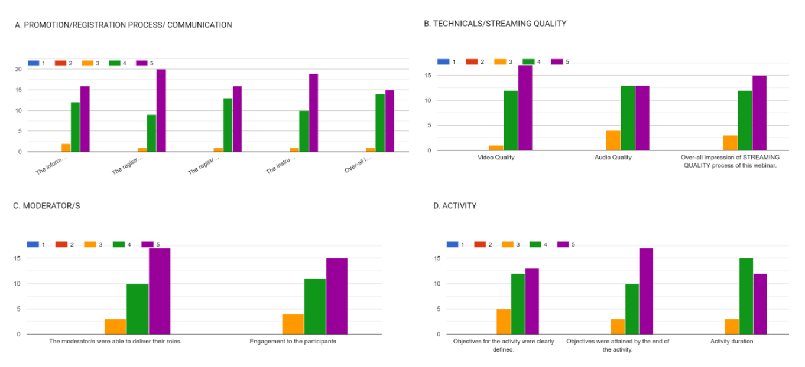**October 27, 2023**

The Brightest Night Gala was the night where students were able to express themselves in the most confident and creative ways. They were given the opportunity to be themselves and walked like they own the night. The said event was beyond measurable as students enjoyed and had fun as they mingled with other students. However, there are some students who raised their opinions with regards to the flow of the activity, where some said that the said *time and schedules must be followed accordingly.* Additionally, they raise their concern about the *taken pictures outside because it was not taken in their most likely shots.* Moreover, some students raised their thoughts about how *they found some parts of the event somehow cliché.* And there are some parts of the event where *they do not understand its purpose.* Overall, most of the students expressed their joyous and gracious recognition to the said event because they truly enjoyed what happened during the Brightest Night Gala. Many of them said that their first Acquaintance Party was truly memorable and funtastic!

**LIQUIDATION REPORT**

**EVENT:** ADHIKA | BUWAN NG WIKA **DATE:** SEPTEMBER 01, 2023

|  |  |  |  |  |
| --- | --- | --- | --- | --- |
| **TRANSACTION DATE** | **PAYEE** | **REFERENCE** | **PARTICULARS** | **AMOUNT** |
| 10-Aug-23 | Graphic Arts (Shopee) | Sales Cash Invoice no. 21026 | Acrylic medal | 490.00 |
| Rivets | 30.00 |
| Express | 30.00 |
| 27-Aug-23 | WWA Enterprises | Sales Cash Invoice no. 10948 | Whiteboard marker (4pcs) | 68.00 |
| Whiteboard eraser (4pcs) | 56.00 |
| 27-Aug-23 | UNITOP General Merchandise Inc. | Collection Receipt no. 0007318 | Whiteboard (4pcs) | 420.00 |
| Illustration board (4 pcs) | 60.00 |
| Eco Bag | 10.00 |
| 28-Aug-23 | Creative Me Printing Solution | Acknowledgement Receipt | Photo print sticker | 50.75 |
| 28-Aug-23 | Althea Native Products | Sales Cash Invoice no. 43807 | Chinese garter | 25.00 |
| 30-Aug-23 | KCC MALL | Sales Cash Invoice no. 543407 | Plastic charol blue | 50.00 |
| Plastic charol red | 50.00 |
| Plastic charol emerald green | 50.00 |
| Plastic charol cream | 50.00 |
| 30-Aug-23 | LAFORTEZA Advertising Services | OR no. 1583 | Tarpaulin | 972.00 |
| 1-Sep-23 | Bayfront Noodle House | OR no. 23827 | Snacks | 600.00 |
| 1-Sep-23 | KCC MALL | Sales Cash Invoice no. 541861 | OK Fruit Drink Orange (3 boxes) | 196.50 |
| OK Fruit Drink Apple (2 boxes) | 131.00 |
| 1-Sep-23 | Freemont Foods Corporation - Jollibee | OR no. 0028015 | Meals | 300.00 |
| 1-Sep-23 | KCC MALL | Sales Cash Invoice no. 541860 | Breadco (5pcks) | 239.00 |
| 1-Sep-23 | Brothers D&D, Inc. - Fitmart | Sales Cash Invoice no. 98756 | Fine arts postmark | 52.75 |
| 1-Sep-23 | Dadiangas Crown Bookstore Inc. | Sales Cash Invoice no. 36800 | Ribbonet (1 roll) | 105.00 |
| 1-Sep-23 | New Brighton School of the Philippines, Inc. | Acknowledgement Receipt | Honorarium | 500.00 |
| **SUBTOTAL** |  |  |  | **4,536.00** |

|  |  |  |  |  |  |
| --- | --- | --- | --- | --- | --- |
| **Transportation Expense** | | | | | |
|  |  |  |  |  |  |
| **DATE** | **FROM** | **TO** | **# of Pax** | **Amount** | **Subtotal** |
| 1-Sep-23 | New Brighton School of the Philippines, Inc. | FitMart Gensan | 1 | 10 | 10 |
| FitMart Gensan | New Brighton School of the Philippines, Inc. | 1 | 10 | 10 |
| **TOTAL** |  |  |  |  | **20** |

|  |  |  |  |  |
| --- | --- | --- | --- | --- |
| **SUMMARY** |  |  |  |  |
| Supplies Expense: | 2464.50 |  | Fund received: | **4556.00** |
| Food Expense: | 1571.50 |  | Total expenses: | **4556.00** |
| Professional Fee: | 500.00 |  |  |  |
| Transportation Expense: | 20.00 |  |  |  |

|  |  |  |
| --- | --- | --- |
| **PREPARED BY:** | | |
|  | **Mary Torrion** | **Ohara Elloren** |
|  | SSC AUDITOR | SSC TREASURER |

|  |  |  |
| --- | --- | --- |
| **CHECKED BY:** | | |
|  | **Maria Bayona** | **Erwil Agbon** |
|  | JPIA PRESIDENT | SSC MODERATOR |

|  |  |  |
| --- | --- | --- |
| **NOTED BY:** | | |
|  | **Romelyn Bitayo** |  |
|  | OSA-Coordinator |  |

**LIQUIDATION REPORT**

**EVENT:** PASIKLABAN 2023 **DATE:** October 21 and 23-26, 2023

|  |  |  |  |  |
| --- | --- | --- | --- | --- |
| **PARTICULAR** | **DATE** | **PARTICULARS** | **OR #** | **AMOUNT** |
| **OPENING** | 14-Oct-23 | Tiebox | Sales Cash Invoice no. 58944 | ₱85.00 |
| Thinner | ₱50.00 |
| Lotus blue | ₱30.00 |
| 14-Oct-23 | Paintbrush | Sales Cash Invoice no. 0073787 | ₱56.00 |
| 14-Oct-23 | Torch lighting wood | Acknowledgement Receipt Control no. 2023-0003 | ₱25.00 |
| 16-Oct-23 | Sulu 5 pcs (₱50 each) | Acknowledgement Receipt Control no. 2023-0004 | ₱250.00 |
| 21-Oct-23 | Gasoline | Sales Cash Invoice no. 0153356 | ₱50.00 |
| 21-Oct-23 | Breads | Sales Cash Invoice no. 125428 | ₱125.00 |
| 21-Oct-23 | Meals | Sales Cash Invoice no. 24653 | ₱750.00 |
| 21-Oct-23 | Ecopro p/plate | Sales Cash Invoice no. 0001467 | ₱58.00 |
| 21-Oct-23 | Coke regular 2L (2pcs) | Sales Cash Invoice no. 0001468 | ₱184.00 |
| Cl 8oz transcup | ₱58.00 |
| 21-Oct-23 | Assorted bread | Acknowledgement Receipt Control No. 2023-0037 | ₱330.00 |
| 21-Oct-23 | Meals | Official Receipt no. 0028281 | ₱225.00 |
| 23-Oct-23 | Double sided tape | Sales Cash Invoice No. 101015 | ₱32.00 |
| Paper sticker matte | ₱45.00 |
| Vellum board | ₱36.00 |
| Vellum board | ₱78.00 |
| **DAY 1 - SPORTS** | 23-Oct-23 | Meals | Official Receipt no. 0028306 | ₱150.00 |
| 23-Oct-23 | Meals | Official Receipt no. 0028307 | ₱150.00 |
| 23-Oct-23 | Coke 1L (12 pcs) | Acknowledgement Receipt Control no. 2023-0040 | ₱1,200.00 |
| 23-Oct-23 | Assorted Groceries | Sales Cash Invoice. 551448 | ₱568.55 |
| 23-Oct-23 | Ecobag L | Sales Cash Invoice no. 551449 | ₱10.00 |
| 23-Oct-23 | 2 kilo rice | Sales Cash Invoice no. 38593 | ₱108.00 |
| 23-Oct-23 | Bariles | Acknowledgement Receipt Control no. 2023-0030 | ₱250.00 |
| 23-Oct-23 | Mineral Water | Acknowledgement Receipt | ₱230.00 |
| 24-Oct-23 | Honorarium | Acknowledgement Receipt Control no. 2023-0028 | ₱2,400.00 |
| **DAY 2 - SPORTS** | 24-Oct-23 | Ecobag | Sales Cash Invoice No. 551208 | ₱10.00 |
| Assorted Groceries | ₱868.40 |
| 24-Oct-23 | 3 kilo rice | Sales Cash Invoice no. 385998 | ₱159.00 |
| 24-Oct-23 | Meals | Official Receipt no. 0003830 | ₱150.00 |
| 24-Oct-23 | Honorarium | Acknowledgement Receipt Control no. 2023-0029 | ₱2,400.00 |
| **DAY 3 - ACADS** | 13-Oct-23 | 4 pcs. of Rubik's Cube (₱49 each) | Sales Cash Invoice No. 0073751 | ₱196.00 |
| 13-Oct-23 | 1 tie of BBQ sticks | Acknowledgement Receipt Control No. 2023-0001 | ₱65.00 |
| 13-Oct-23 | 4 pcs of Handkerchief (₱35 each) | Acknowledgement Receipt Control No. 2023-0002 | ₱140.00 |
| 25-Oct-23 | Assorted Bread | Sales Cash Invoice No. 0158 | ₱380.00 |
| 25-Oct-23 | 3 boxes of Ham & Cheese | Official Receipt No. 00229 | ₱225.00 |
| 3 boxes of Hawaiian | ₱255.00 |
| 25-Oct-23 | Vellum board | Sales Cash Invoice No. 82026 | ₱224.00 |
| 25-Oct-23 | Meals | Official Receipt No. 24718 | ₱450.00 |
| **AWARDING** | 7-Oct-23 | Acrylic Plaque Blank | Official Receipt No. 3166 | ₱1,193.00 |
| 13-Oct-23 | 8 pcs of Non-woven Wrapper (₱24 each) | Sales Invoice No. 0073752 | ₱192.00 |
| 13-Oct-23 | Satin Ribbon | Cash Sales Invoice No. 550770 | ₱600.00 |
| 25-Oct-23 | 3 bottles of 1.5L Coke (₱79 each) | Cash Invoice No. 0001473 | ₱237.00 |
| 26-Oct-23 | Assorted Bread | Receipt | ₱385.00 |
| 26-Oct-23 | Ecobag | Receipt | ₱10.00 |
| 26-Oct-23 | Muffins | Receipt | ₱692.00 |
| 26-Oct-23 | Meals | Official Receipt No. 0023505 | ₱750.00 |
| 26-Oct-23 | Distilled water 500 ml | Cash Sale Invoice No. 548176 | ₱44.55 |
| 26-Oct-23 | Talent fee (judge) | Acknowledgement Receipt No. 2023-0035 | ₱1,000.00 |
| 26-Oct-23 | Talent fee (judge) | Acknowledgement Receipt No. 2023-0033 | ₱1,000.00 |
| 26-Oct-23 | Talent fee (judge) | Acknowledgement Receipt No. 2023-0034 | ₱1,000.00 |
| **DECORATION** | 21-Oct-23 | Tarpaulin | Official Receipt No. 1728 | ₱1,716.00 |
| **MATERIALS** | 13-Oct-23 | 5 packs of Vellum Board (₱36 each) | Sales Cash Invoice No. 81487 | ₱180.00 |
| 23-Oct-23 | 1 pack glossy sticker paper | Sales Invoice No. 000281745 | ₱48.00 |
| 26-Oct-23 | Sticker for Plaques | Official Receipt No. 2921 | ₱250.00 |
| **CONTINGENCY** | 10-Oct-23 | P. colored for banderitas 24 pcs (₱19 each) | Sales Cash Invoice No. 41305 | ₱456.00 |
| 10-Oct-23 | Shower curtain for banderitas | Sales Cash Invoice No. 27610 | ₱70.00 |
| 10-Oct-23 | Thumbtacks | Sales Cash Invoice No. 000280747 | ₱6.00 |
| 13-Oct-23 | Envelope brown long | Sales Cash Invoice No. 38288 | ₱10.00 |
| 16-Oct-23 | DSR permit | Official Receipt GS No. 0904915A | ₱200.00 |
| 19-Oct-23 | Cartolina | Receipt | ₱48.00 |
| Sticky note | ₱109.50 |
| Sticky note | ₱219.00 |
| Sticky note | ₱85.50 |
| Fine board vellum s | ₱116.00 |
| Fine board vellum L | ₱66.00 |
| 20-Oct-23 | P/C QDE LEM.YLW | Sales Cash Invoice No. 18724 | ₱75.00 |
| PB # 1 | ₱30.00 |
| 20-Oct-23 | Satin ribbon emerald green | Sales Cash Invoice No. 553194 | ₱40.00 |
| Sports basketball scorebook | ₱64.75 |
| Aktive volleyball scorebook | ₱69.75 |
| Chipboard | ₱129.00 |
| 21-Oct-23 | Lamination of gatepass | Official Receipt No. 00751 | ₱320.00 |
| 23-Oct-23 | Pingpong table and net rental for two days | Receipt | ₱1,500.00 |
| 25-Oct-23 | Meals | Official Receipt No. 0028316 | ₱314.00 |
| 25-Oct-23 | Shoutcaster's honorarium | Acknowledgement Receipt Control No. 2023-0031 | ₱500.00 |
| 25-Oct-23 | Shoutcaster's honorarium | Acknowledgement Receipt Control No. 2023-0032 | ₱500.00 |
| **DIVISION BUDGET** |  | PASIKLABAN MATERIALS | ***please see attached file*** | ₱20,000.00 |
|  |  |  | TOTAL | **₱47,282.00** |

|  |  |  |
| --- | --- | --- |
| **Transportation Expense** | | |
| **DATE** | **TAR #** | **FROM** | | **TO** | **NUMBER OF PAX** | **AMOUNT** | **TOTAL** |
| 13-Oct-23 | TAR 2023-0001 | NBSPI | | UNITOP | 2 | ₱15.00 | ₱30.00 |
| 13-Oct-23 | TAR 2023-0002 | PUBLIC MARKET | | CROWN BOOKSTORE | 2 | ₱15.00 | ₱30.00 |
| 14-Oct-23 | TAR 2023-0003 | NBSPI | | UNITOP | 2 | ₱15.00 | ₱30.00 |
| 14-Oct-23 | TAR 2023-0004 | PUBLIC MARKET | | NBSPI | 2 | ₱15.00 | ₱30.00 |
| 20-Oct-23 | TAR 2023-0005 | KCC MALL | | NBSPI | 3 | ₱15.00 | ₱45.00 |
| 20-Oct-23 | TAR 2023-0006 | PUBLIC MARKET | | NBSPI | 2 | ₱15.00 | ₱30.00 |
| 20-Oct-23 | TAR 2023-0007 | NBSPI | | KCC MALL | 3 | ₱15.00 | ₱45.00 |
| 21-Oct-23 | TAR 2023-0008 | NBSPI | | LAFORTEZA ADVERTISING SERVICE | 1 | ₱40.00 | ₱40.00 |
| LAFORTEZA ADVERTISING SERVICE | | NSBPI |
| 13-Oct-23 | TAR 2023-0009 | KRISTAN BOOKSTORE | | NBSPI | 2 | 10 | ₱20.00 |
| 21-Oct-23 | TAR 2023-0010 | NBSPI | | PUBLIC MARKET | 1 | ₱15.00 | ₱15.00 |
| 21-Oct-23 | TAR 2023-0055 | PUBLIC MARKET | | NBSPI | 1 | ₱15.00 | ₱15.00 |
| 21-Oct-23 | TAR 2023-0056 | NBSPI | | STARBRIGHT | 2 | ₱15.00 | ₱30.00 |
| 21-Oct-23 | TAR 2023-0057 | STARBRIGHT | | NBSPI | 2 | ₱15.00 | ₱30.00 |
| 23-Oct-23 | TAR 2023-0058 | NBSPI | | FITMART | 1 | ₱15.00 | ₱15.00 |
| 25-Oct-23 | TAR 2023-0059 | NBSPI | | FITMART | 4 | ₱15.00 | ₱60.00 |
| 25-Oct-23 | TAR 2023-0060 | FITMART | | NBSPI | 4 | ₱15.00 | ₱60.00 |
| 23-Oct-23 | TAR 2023-0061 | FITMART | | NBSPI | 1 | ₱15.00 | ₱15.00 |
| 23-Oct-23 | TAR 2023-0062 | NBSPI | | KCC MALL | 2 | ₱15.00 | ₱30.00 |
| 23-Oct-23 | TAR 2023-0063 | KCC MALL | | NBSPI | 2 | ₱15.00 | ₱30.00 |
| 23-Oct-23 | TAR 2023-0064 | NBSPI | | JOLLIBEE PLAZA | 2 | ₱15.00 | ₱30.00 |
| 23-Oct-23 | TAR 2023-0065 | JOLLIBEE PLAZA | | NBSPI | 2 | ₱15.00 | ₱30.00 |
| 24-Oct-23 | TAR 2023-0066 | NBSPI | | FRIENDLY MART | 2 | ₱15.00 | ₱30.00 |
| 24-Oct-23 | TAR 2023-0068 | FRIENDLY MART | | NBSPI | 2 | ₱15.00 | ₱30.00 |
| 26-Oct-23 | TAR 2023-0069 | NBSPI | | VERANZA | 5 | ₱15.00 | ₱75.00 |
| 26-Oct-23 | TAR 2023-0070 | NBSPI | | VERANZA | 4 | ₱15.00 | ₱60.00 |
|  |  |  | |  |  |  |  |
|  |  |  | |  |  | TOTAL | ₱855.00 |

|  |  |  |
| --- | --- | --- |
| **PASIKLABAN BUDGET** | | **₱52,265.00** |
|  |  |  |
| **TOTAL EXPENSES** | **₱47,282.00** |  |
| **TRANSPORTATION FEE** | **₱855.00** |  |
|  | | **₱48,137.00** |

|  |  |  |  |
| --- | --- | --- | --- |
| **REMAINING FUND** | |  | **₱4,128.00** |
| **PREPARED BY:** | | |
|  | **Mary Torrion** | **Ohara Elloren** |
|  | SSC AUDITOR | SSC TREASURER |

|  |  |  |
| --- | --- | --- |
| **CHECKED BY:** | | |
|  | **Maria Bayona** | **Erwil Agbon** |
|  | JPIA PRESIDENT | SSC MODERATOR |

|  |  |  |
| --- | --- | --- |
| **NOTED BY:** | | |
|  | **Romelyn Bitayo** |  |
|  | OSA-Coordinator |  |

**LIQUIDATION REPORT**

**EVENT:** BRIGHTEST NIGHT GALA 2023 **DATE:** October 27, 2023

|  |  |  |  |  |  |  |  |  |  |  |  |  |  |  |  |  |  |  |  |  |  |  |  |  |  |  |  |  |  |  |  |  |  |  |  |  |  |  |  |  |  |  |  |  |  |  |  |  |  |  |  |  |  |  |  |  |  |  |  |  |  |  |  |  |  |  |  |  |  |  |  |  |  |  |  |  |  |  |  |  |  |  |  |  |  |  |  |  |  |  |  |  |  |  |  |  |  |  |  |  |  |  |  |  |  |  |  |  |  |  |  |  |  |  |  |  |  |  |  |  |  |  |  |  |  |  |  |
| --- | --- | --- | --- | --- | --- | --- | --- | --- | --- | --- | --- | --- | --- | --- | --- | --- | --- | --- | --- | --- | --- | --- | --- | --- | --- | --- | --- | --- | --- | --- | --- | --- | --- | --- | --- | --- | --- | --- | --- | --- | --- | --- | --- | --- | --- | --- | --- | --- | --- | --- | --- | --- | --- | --- | --- | --- | --- | --- | --- | --- | --- | --- | --- | --- | --- | --- | --- | --- | --- | --- | --- | --- | --- | --- | --- | --- | --- | --- | --- | --- | --- | --- | --- | --- | --- | --- | --- | --- | --- | --- | --- | --- | --- | --- | --- | --- | --- | --- | --- | --- | --- | --- | --- | --- | --- | --- | --- | --- | --- | --- | --- | --- | --- | --- | --- | --- | --- | --- | --- | --- | --- | --- | --- | --- | --- | --- | --- |
| |  |  |  |  | | --- | --- | --- | --- | | **DATE** | **PARTICULARS** | **OR #** | **AMOUNT** | | 10-Oct-23 | 2 pcs of Crown Gold King (₱110 each) | Sales Cash Invoice No. 11418 | ₱220.00 | | 17-Oct-23 | Souvenir | Sales Invoice No. 0066 | ₱27,032.00 | | 16-Oct-23 | Shipping Fee for Souvenir | Shopee Checkout | ₱2,096.00 | | 19-Oct-23 | BeToteful Logo Contest | Acknowledgement Receipt No. 2023-0005 | ₱550.00 | | 20-Oct-23 | Crown Assorted | Cash Sales Invoice No. 553193 | ₱319.75 | | Crown Assorted | ₱259.75 | | Arc Mirror | ₱1,999.75 | | Kangaro Staples | ₱210.50 | | 20-Oct-23 | LED Light 2 pcs (699 each) | Sales Invoice No. 0073919 | ₱1,398.00 | | 24-Oct-23 | Phela Grande Catering Services | Official Receipt No. 42942 | ₱222,864.00 | | 20-Oct-23 | Event Decoration | Official Receipt No. 1314 | ₱10,000.00 | | 26-Oct-23 | Tarpaulin for photowall | Official Receipt No. 40651 | ₱1,080.00 | | 26-Oct-23 | Transportaion for Socio and Instruments | Acknowledgement Receipt No. 20230036 | ₱1,000.00 | | 27-Oct-23 | Print Sticker for Arc Mirror | Official Receipt No. 2927 | ₱150.00 | | 27-Oct-23 | Photography and Videography fee | Acknowledgement Receipt | ₱5,000.00 | | 27-Oct-23 | Disk Jockey Fee | Acknowledgement Receipt | ₱4,000.00 | | 27-Oct-23 | Honorarium for Emcee | Acknowledgement Receipt | ₱2,500.00 | | 27-Oct-23 | Payment for 1 hour extension | Acknowledgement Receipt | ₱2,500.00 | |  |  | TOTAL | **₱283,179.75** |   **Transportation Expense**   |  |  |  |  |  |  |  | | --- | --- | --- | --- | --- | --- | --- | | **DATE** | **TAR #** | **FROM** | **TO** | **NUMBER OF PAX** | **AMOUNT** | **TOTAL** | | 27-Oct-23 |  | Phela Grande Convention | New Brighton School of the Philippines, Inc. | 16 | 25 | ₱400.00 | |  |  |  |  |  | TOTAL | ₱400.00 |   Summary:   |  |  |  | | --- | --- | --- | | **BRIGHTEST NIGHT GALA BUDGET** | | **₱285,450.00** | | **TOTAL EXPENSES** | **₱283,179.75** |  | | **TRANSPORTATION FEE** | **₱400.00** |  | | **TOTAL EXPENSES** | | **₱283,579.75** |  |  |  |  | | --- | --- | --- | | **CASH REQUESTED** |  | **₱285,450.00** | | **EXPENSES** |  | ₱283,579.75 | | MATERIALS | ₱283,179.75 |  | | TRANSPORTATION FEE | ₱400.00 |  | | **REMAINING FEE** |  | **₱1,870.25** | |  |  |  |   **PREPARED BY:** | | |
|  | **Mary Torrion** | **Ohara Elloren** |
|  | SSC AUDITOR | SSC TREASURER |

|  |  |  |
| --- | --- | --- |
| **CHECKED BY:** | | |
|  | **Maria Bayona** | **Erwil Agbon** |
|  | JPIA PRESIDENT | SSC MODERATOR |

|  |  |  |
| --- | --- | --- |
| **NOTED BY:** | | |
|  | **Romelyn Bitayo** |  |
|  | OSA-Coordinator |  |

**PROPOSED CALENDAR OF ACTIVITIES FOR 2ND SEMESTER**

**2024**

**JANUARY**

**23** 1st General Assembly

**FEBRUARY**

**16** Hearts’ Day

**23** 2nd General Assembly

**March**

**30** NBSPI Days (Opening)

**April**

**01 – 04** NBSPI Days

**12** 3rd General Assembly

**26 – 27** Clubs’ Day

**PROPOSED ACTIVITIES**

**HEARTS’ DAY (TEACHERS’ AND STUDENTS’ DAY)**

**February 16, 2024**

**RATIONALE:** The attributes that help teachers and students form a meaningful relationship that promotes connection and mutual growth include patience, guidance, and inspiration.

**THEME**: PAG-IBIG (Patience and Guidance: In Building Inspiration Generations)

* Date- February 16,2024 (Friday)
* 1 – 5 PM
* Auditorium

**MORNING ACTIVITIES**

**Valentine's Card-Making Station:**

*Set up a station with art supplies where students and teachers can create personalized Valentine's Day cards for their loved ones.*

* Red Card stands for In love
* Yellow Card stands for Hoping
* Light Blue stands for Thankful/Grateful
* Pink Card stands for Admiring
* Orange Card stands for an open letter for our teachers

***Estimated Cost: P500.00***

**“Suot Ko, Feelings Ko!” or “Wear Your Heart In Color”:**

*A colorful and expressive event where people can express their feelings and emotions on Valentine's Day through color. Teachers and students are free to modify it to fit the particular theme or ambiance they like to create for our event.*

* Red Color (In a Relationship)
* Yellow Color (Mutual Understanding)
* Orange Color (It’s Complicated)
* White Color (Single)
* Green Color (Study First)
* Blue (Not into Romantic Relationship)
* Pink Color (Happy Crush)
* Black Color (Broken Hearted)
* Brown Color (Waiting for Someone)

**"KODAKK: A Valentine's Photo Selfie Experience":**

*The idea of capturing moments with the iconic brand name, suggesting a focus on preserving special memories during the Valentine's Day celebration.*

***Estimated Cost: P500.00***

**"NGL: Confessions of the Heart":**

*A safe and intimate space for individuals to share their heartfelt confessions and express their emotions during Valentine's Day. A love letter exchanging anonymously.*

**ACTIVITIES DURING PROPER PROGRAM (afternoon)**

**GAMES**:

* “ORA, LABORA”
  + 5 Participants per Division: 3 students and 2 teachers
* “MINUTE TO WIN IT”
  + 5 Participants per Division: 3 students and 2 teachers
* “EAT ALL YOU CAN”
  + 10 Participants per Division: 7 students and 3 teachers
* “PAINT ME A PICTURE”
  + 10 Participants per team (2 teams): combination of teachers and students
* “ACT KO, SAGOT MO” (charades game)
  + 5 Participants per Team: 3 students and 2 teachers

***Estimated Cost: P1,000.00***

**TOTAL ESTIMATED BUDGET: P2,000.00**

**CLUB/S INVOLVED:**

* Sirius Publication (Documentation)

**PROPOSED ACTIVITIES**

**NBSPI DAYS**

**March 30 and 01 - 04, 2024**

**RATIONALE:** NBSPI DAYS often include traditional Filipino activities to promote cultural awareness, unity, and a sense of identity among participants. These activities celebrate Filipino heritage and foster camaraderie through sports, indigenous games, and folk dances, reflecting the rich cultural diversity of the country. NBSPI Days serve as a platform to instill national pride and values while encouraging physical activity and teamwork. Incorporating traditional sports, games, and dances not only provides a unique and enjoyable experience but also helps in passing down cultural values and fostering a connection to the country's rich history. Additionally, these activities contribute to a holistic approach to education, emphasizing physical well-being, teamwork, and an appreciation for cultural diversity.

**BUDGET PROPOSAL:**

**ACTIVITIES UNDER SOCIO-CULTURAL:** Folkdance Competition**,** Hip-Hop Competition**,** OPM Songs Competition (duo category)**,** Torch Bearer (Mr. & Ms. NBSPI)**,** Yell Competition**,** and Festival Dance Competition

***Estimated Cost: P7,500.00***

**ACTIVITIES UNDER SPORTS:** Basketball Competition (boys), Volleyball Competition (girls & boys)**,** Takraw Competition**,** Badminton Competition**,** Table Tennis Competition**,** and Dart

***Estimated Cost: P4,000.00***

**ACTIVITIES UNDER ACADEMIC:** Brighton Henyo**,** Division Feud**,** Rubiks cube**,** Tagisan ng Talino**,** Debate**,** Spoken Poetry, Extemporaneous speech**,** and ESPORTS (MLand Codm)

***Estimated Cost: P3,000.00***

**TOTAL ESTIMATED BUDGET: P14,500.00**

**CLUB/S INVOLVED:**

* Sirius Publication (Documentation)
* First Aiders Club (Medical Assistance)
* Socio-cultural Club

**PROPOSED ACTIVITIES**

**LEADERSHIP BOOST: CLUBS’ DAY EDITION**

**April 26 - 27, 2024**

**RATIONALE:** The title "Leadership Boost: Club Day Edition" conveys the essence of the event succinctly. "Leadership Boost" communicates the primary focus on enhancing leadership skills, while "Club Day Edition" indicates a specific and engaging event tailored for clubs. The simplicity ensures clarity and instant understanding of the event's purpose, making it appealing and accessible to a broad audience.Join us at "Leadership Boost: Club Day Edition" for an immersive experience designed to elevate your leadership skills. This special edition is crafted with clubs in mind, offering practical insights, collaborative activities, and networking opportunities. Dive into a day of growth and empowerment, where you'll gain valuable tools to navigate the leadership landscape within your club. Don't miss this chance to boost your leadership potential and make a lasting impact. See you at the event!

**BUDGET PROPOSAL**: This budget proposal aims to ensure a high-quality "Leadership Boost: Club Day Edition" with experienced speakers, engaging activities, and a conducive environment for learning and networking. Adjustments can be made based on specific needs and available resources.

1. Speaker/Trainer Fees:

Engage experienced leadership trainers or speakers.

***Estimated Cost: P1,500.00***

1. Materials and Supplies:

Printing of workshop materials, name tags, and stationery.

***Estimated Cost: P1,000.00***

1. Refreshments:

Provide snacks and beverages for attendees (breakfast, lunch, and dinner).

***Estimated Cost: P5,000.00***

1. Decor and Signage:

Create a vibrant and engaging atmosphere.

***Estimated Cost: P500.00***

1. Promotional Materials:

Design and printing Tarpaulin.

***Estimated Cost: P500.00***

1. Registration fee:

For games and activities.

***Estimated Cost: P200.00/student***

1. Contingency Fund:

Set aside a 10% contingency for unforeseen expenses.

***Estimated Cost: P500.00***

**TOTAL ESTIMATED BUDGET: P9,000.00**

**CLUB/S INVOLVED:**

1. Supreme Student Council
2. Sirius Publication
3. Math-Sci Club
4. First Aiders Club
5. Socio-cultural Club
6. Junior Entrepreneur Council (JEC)
7. Junior Philippine Institution of Accountants (JPIA)
8. Fedhoms
9. DevCom Society
10. Peer Facilitators Club
11. Sports Club
12. Literary Group
13. Philippine Society of Information Technology (PSITS)
14. Junior Philippine Association of Management Accountants (JPAMA)